Artesia Arts & Cultural District
Downtown Mural Program

Request For Proposals
The Artesia Arts & Cultural District is currently accepting proposals for a public art mural in our downtown area. This mural will be the latest in a continuing series of downtown public art installations, in support of the Arts in Artesia.
Project Description: The mural’s overall design should be timeless. The location’s setting and existing building elements should be incorporated into the overall design. (This site is near another mural) In addition, the design must have an interactive component to it that people can pose with that will engage pedestrians, but nothing that requires mounting, drilling, or any other method of affixing. Subject matter should celebrate one or more of: The City of Artesia, Eddy County, New Mexico, local history, cultures, character, architecture, and/or uniqueness. All artworks must be appropriate for all ages. No: obscenities, nudity, sexual content, profanity, substance abuse, scary imagery, racism, violence, degradation or desecration of individuals/groups/cultural symbols, or gang-related designs. Artists will retain the ownership of design ideas submitted with this application. The winning design’s ownership will become the property of the Artesia Arts & Cultural District upon completion of the mural, along with all artworks produced for this mural.

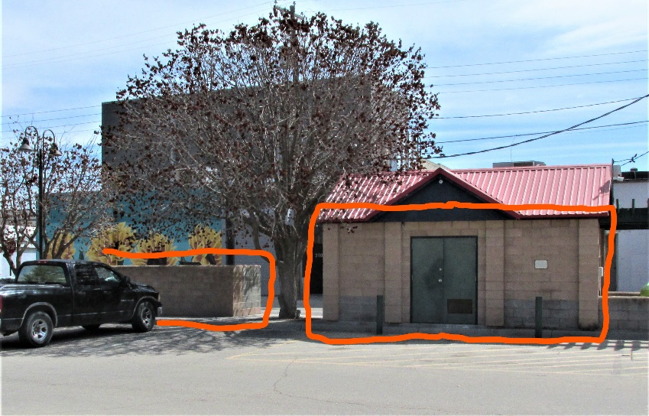
Trash Enclosure: north & west side Pump House: north side
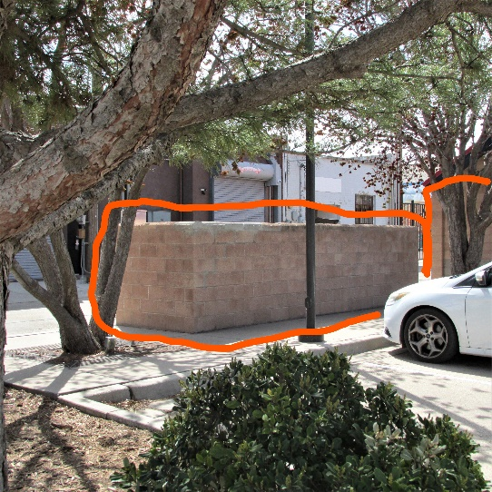
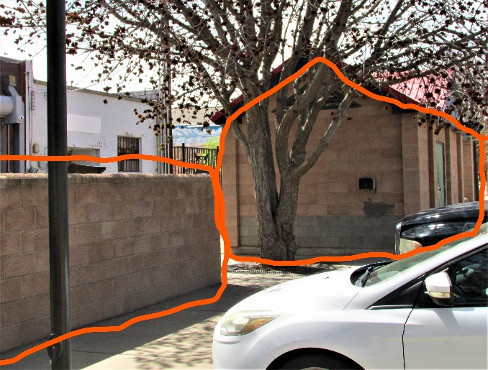
Trash Enclosure: east & north side Trash Enclosure: north side Pump House: east & north side
Site Information: The site for this mural is on the north and east walls of the Heritage Plaza Pump House + adjacent trash enclosure walls (behind 310-316 West Main St., Artesia NM). The mural walls and trash enclosure measure approximately 20’6” X 7’8” & 12’8” X 7’8” + 250 sq. ft. (Pump House north & east sides) and 6’ X 5’3” (trash enclosure east and west sides) & 20’ X 5’3” (trash enclosure north side) and are built from rough granite-type blocks. This site is the central location for many Artesia festivals and events.
Funding: A stipend of $5,000.00 will be awarded to the selected artist or team of artists. The Artesia Arts & Cultural District & site owner will pay for materials, provide equipment, and take care of pressure-washing and site repairs. ACD can also assist with lodging information.

Application Requirements: All artists must be over age 18.
- A completed application form
- An artist’s resume + examples of work to demonstrate the artist(s)‘s ability to complete a project of this scale in the timeframe allowed + 2 references.
- 2-4 concept sketches, and an Artist’s Statement (400 words maximum) explaining the inspiration behind the design.
- A time-frame schedule for the installation—exact dates to be worked out
- A budget for materials—applicants are responsible for doing their own site surveys, including necessary equipment assessments.
- Both the Artesia Arts & Cultural District and the selected artist(s) agree to release and hold harmless the other in any case of liability related to the preparation and/or installation of the mural. This provision shall remain in effect beyond the expiration of the term.
- All submission materials are due by April 25, 2023. All submission materials should be submitted to: acdmurals@gmail.com
Selection Process: The winning design will be chosen by an Artesia Arts & Cultural District selection team.

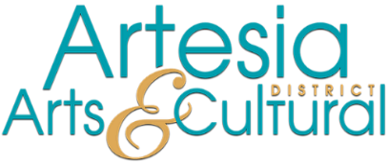
DOWNTOWN MURAL PROJECT
APPLICATION

Full Name
If applying as team, please select a contact person.
Website | Click or tap here to enter text.
Phone | Click or tap here to enter text.
Email | Click or tap here to enter text.
Address | Click or tap here to enter text.
City
State
Zip Code
Mailing Address, if different | Click or tap here to enter text.

As an applicant for the Artesia Arts & Cultural District’s Downtown Mural Project, I certify that all works submitted are original products of the applicant(s) and no other. I further certify that all statements made in this application are true to the best of my knowledge.

Applicant signature: Click or tap here to enter text.
Date: Click or tap to enter a date.

